**Lifestyle Resources and information: Physical Activity**

**Resources:**

**One You - Public Health England**

<https://campaignresources.phe.gov.uk/resources/campaigns/44-one-you/Physical%20Activity>

Resources, advice, fact sheets and apps on getting moving and keeping moving.

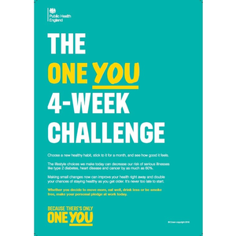 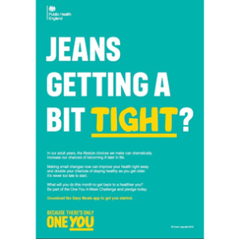 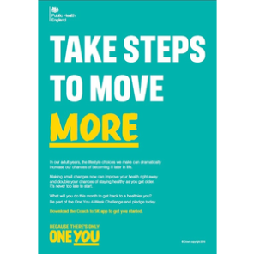

**NHS Choices**

<http://www.nhs.uk/Livewell/fitness/Pages/physical-activity-guidelines-for-adults.aspx>

<http://www.nhs.uk/Livewell/getting-started-guides/Pages/getting-started-guides.aspx>

<http://www.nhs.uk/livewell/fitness/Pages/Fitnesshome.aspx>

The website provides guidance, fact sheets, apps, case studies on physical activity for all levels.

**APPS:**

**Couch to 5K App – NHS Choices**



<http://www.nhs.uk/LiveWell/c25k/Pages/couch-to-5k.aspx>

Couch to 5K has been designed to get people off the couch and running in just 9 weeks. There are step-by-step instructions with this free app.

**Change for Life App’s**

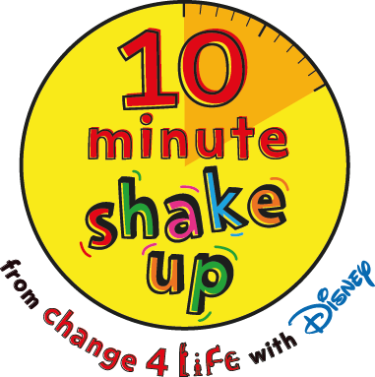

<http://www.nhs.uk/change4life/pages/active-hobby-ideas.aspx>

<http://www.nhs.uk/Change4Life/Pages/be-more-active.aspx>

<https://www.nhs.uk/10-minute-shake-up/shake-ups>

Practical apps and information for families and children to use to increase their physical activity levels.

**Local groups to access for physical activity:**

**Our Gateshead -** Gateshead’s Community Service

<http://www.ourgateshead.org/>

A local site which includes a list local groups to access for physical activity, a health and wellbeing directory of activities and a ‘what’s on guide’ to the local area by topic area.

**Go Gateshead**

Information and Time tables for Gateshead Leisure Centres and Pools

<http://www.gateshead.gov.uk/Leisure%20and%20Culture/leisure-sport-and-fitness/home.aspx>